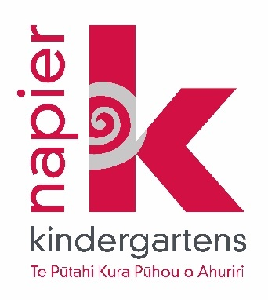

**Job Vacancies**

1. **Wharerangi Kindergarten - .8 Teacher**
2. **Wairoa Kindergarten - Full-time Teacher**

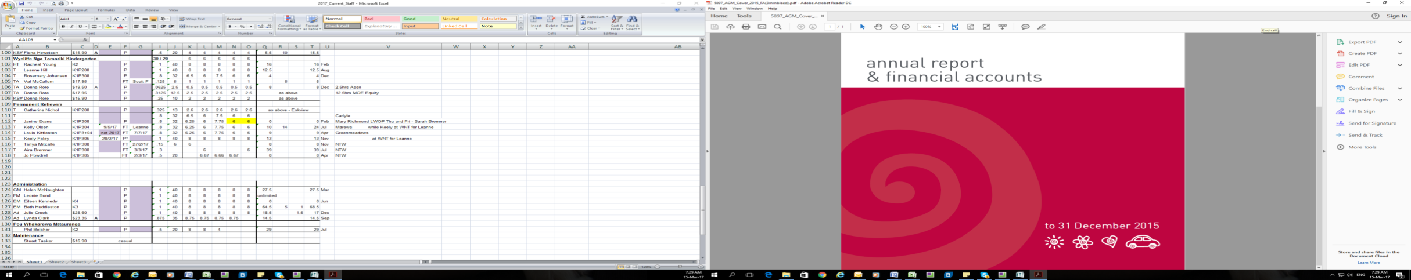

**Who we are - The Association**

Napier Kindergarten Association has operated as a community based, not for profit organisation since 1951. It is overseen by a governing board of up to nine members, eight of whom are elected by parent and life members, as well as one member elected by employees.

Our Association operates 16 kindergartens (two of which are based in Wairoa), employs over 70 teaching staff and 16 Kindergarten Support Workers, and maintains a pool of Relievers and additional support personnel.

We are committed to delivering high quality education by employing fully trained registered teachers using a curriculum based on Te Ara Whānui.

All our kindergartens are licenced for children aged 2 to 5 years and offer a six-hour session and in some kindergartens a morning session for the children enrolled.

Our teacher to child ratio is 1:10. Each kindergarten employs an additional above ratio support person (Kindergarten Support Worker) to assist predominantly with non-teaching work.

Four of our kindergartens offer an ‘extended year’ service (which means they are open for term breaks, and re-open early in the New Year). These are Wharerangi Kindergarten, Bette Christie Kindergarten, Wycliffe Ngā Tamariki Kindergarten and Taradale East Kindergarten.

Starting salary levels for teachers are determined as per the Kindergarten Teachers Collective Agreement, considering teaching qualifications and experience.

We offer excellent professional development opportunities and paid professional time within the guidelines of the Kindergarten Teachers Collective Agreement. Additional individual professional development opportunities are available. We also offer an excellent mentoring programme for provisionally registered teachers.

The Association is an equal employment opportunities employer.

All permanent employees in positions of 15 hours or more per week are included in our group life insurance scheme (paid for by the Association) which provides life cover of $100,000 (payable to your nominated person or estate).

**Who we are looking for - The Person**

It is essential that our teachers support their teams to create a warm, welcoming atmosphere for all, where the importance of Māori as tangata whenua is evident and there is an intercultural environment where all children's cultural backgrounds are acknowledged.

We expect our teachers to be persons of high integrity and professionalism. Our teachers must be willing to actively contribute towards creating cohesive, inclusive, and high functioning teams which encourage respect for diverse views and support teaching colleagues of varying levels of experience to excel and achieve.

In addition to the duties described in the job description, we are looking for teachers with the following skills, attributes, qualifications, and abilities:

* Full or provisional registration
* Are inspired, inspiring, passionate, and committed to ongoing professional development
* Are involved, personable and welcoming, bringing a sense of joy, warmth and enthusiasm to their work.
* Are confident communicators and have excellent adult interpersonal and conflict resolution skills. Able to contribute to a positive, respectful, and professional team culture.
* Value the care of children
* Believe in and are willing to be partners in the Association and the kindergarten family vision
* Are flexible, forward thinking, and capable of using initiative
* Will operate within Association policies and guidelines
* Exercise good judgement and discernment
* Have a commitment to Te Reo me ngā Tikanga Māori
* Have an interest in and empathy for sustainable education
* Can build and foster community spirit
* Have excellent time management skills
* Have competent computer skills
* A willingness to expand knowledge of the cultures of the children attending the kindergarten
* The ability to market and represent the kindergarten well in a competitive environment.

All Napier Kindergarten Association teachers are required to have current first-aid training, comply with any Public Health Order mandates that may be in place and attend all staff meetings, professional development and in-house training meetings that are organised throughout any year.

A high standard of performance is expected from teachers in the Napier Kindergarten Association.  In return for this, the Association offers generous support and working conditions for all teachers.

**What we are offering - The Kindergartens and Positions**

**Wairoa Kindergarten** – ***18a Brian Ave, Wairoa***

We are situated in the heart of Wairoa township with large and attractive grounds for outdoor play. Our children join us from a large geographic area encompassing our town and the wider farming communities.

The ideal applicant will be able to demonstrate a high level of commitment to understanding and applying Te Ao Māori concepts such as manaakitanga and whakawhanaungatanga and linking these to the Te Whāriki curriculum in their daily practice and to growing in this area alongside your colleagues.

Wairoa Kindergarten’s Philosophy

Wairoa Kindergarten is built on the foundations of Aroha and Whakawhānaungatanga.

* The uniqueness of our rohe and tangata whenua guides our kaupapa.
* We take pride in providing a safe and nurturing environment where creativity thrives.

*Whakatauki*

*Inā kei te mōhio koe ko wai koe, i anga mai koe i hea, kei te mōhio koe kei te anga atu ki hea.*

*(If you know who you are and where you are from, then you will know where you are going).*

We deliver a daily 6-hour session during term times aligned with Primary School term breaks. Our current roll is approx. 30 children with room to grow the enrolments further. Wairoa Kindergarten offers the KidsCan lunch programme providing free lunch for tamariki and staff. This is delivered by our KSW and is highly popular.

Our kindergarten caters for children ages 2 to 5. Experience and appreciation of the needs of two-year-olds and a willingness to support their transition into kindergarten in a calm and reassuring manner would be an advantage.

The Association’s Education Manager regularly visits Wairoa and provides opportunities for in house training and meetings. However, from time-to-time Wairoa teachers may be required to attend the Association Conference and professional development opportunities in Napier for which travel and accommodation costs will be covered by the Association.

We are prepared to negotiate assistance with relocation costs to those living outside of Wairoa.

**Position** *–* ***Full-time Teacher***

Hours: Mon to Fri 8.00am to 4.30pm including a 30-minute unpaid lunch break.

* Session time is 8.30am to 2.30pm.
* Professional time (non-contact) of 12.5 hours per week including two hours collective professional time on Wed afternoon from 2.30pm until 4.30pm

**Wharerangi Kindergarten** – ***13 Essex St, Tamatea***

Wharerangi Kindergarten is situated in the suburb of Tamatea – a culturally and socio-economically diverse community. The kindergarten is vibrant and responsive to community needs with a strong focus on developing and respecting relationships with whānau.

Wharerangi Kindergarten’s Philosophy

Our children and whānau will belong to a calm, engaging and colourful community where children learn through play supported by teachers who are nurturing and passionate.

* Calm is a mindful atmosphere that nurtures the senses.
* Engaging is the freedom to interact with people, places, and things.
* A colourful community is connecting with others: a place for all.
* A nurturing teacher builds intimate relationships while holding the space.
* A passionate teacher is an evolving teacher.

Play is learning

Play is the work of children which nurtures and grows the whole child.

Play is an essential part of a child's social, emotional, physical, and cognitive development. At Wharerangi Kindergarten play is a vital part of every child's development. It allows them to test ideas, work through uncertainties, explore social interactions and make sense of the world around them.

Play has no predetermined outcome or time limit. It is not about an end product but about a process. It's the exploration of ideas that is crucial.

Play is children's work.

We emphasise the passionate and nurturing qualities with a free play focus. The ideal applicant will be able to demonstrate an understanding and appreciation of the diverse needs of children aged 2 – 5 years in a large social setting.

We are seeking a teacher to join our team who is purposeful, collaborative, colourful and solution focused – a person who delights in the privilege of working with and alongside children.

Wharerangi Kindergarten has a roll of 40 children, and a team of two fulltime teachers, two parttime teachers and a KSW. The kindergarten provides a 4 ¼ hour morning session in conjunction with a 6 hour session, Monday to Friday.

**Position** *–* ***.8 Teacher***

**Wharerangi Kindergarten is one of four Association kindergartens that operate an extended year service. This means the kindergarten does not close for term breaks and is only closed for approx. 2 to 2.5 weeks over the Christmas/New Year period.**

The teaching team co-ordinates their annual and professional leave throughout the year to ensure there is always a core of permanent teaching staff at the kindergarten each week. There is an expectation that all teachers will work during traditional term breaks on a regular basis so that all team members have the opportunity to take leave during some term breaks as well as during term time.

Hours: Mon, Tue, Thu, Fri 8.15am to 2.45pm including a 30-minute unpaid lunch break.

Wed 8.00am to 4:30pm including a 30-minute unpaid lunch break.

* Session time is 8.30am to 2.30pm.
* Professional time (non-contact) of 8.25 hours per week including two hours collective professional time on Wed afternoon from 2.30pm until 4.30pm